SOP: CHANGING OWN PASSWORD IN IORPMS
(Last updated: October 2025)
Background | Changing own user password
Objective | To provide a simplified procedure for changing own password in IORPMS
Who | Logged in user
Required Materials | - IORPMS software site www.localhost/iorpms/  - No internet required

Step | Action | Screenshots
 | Login using your saved username e.g. ‘pharmacist’ password = ‘123456’ | 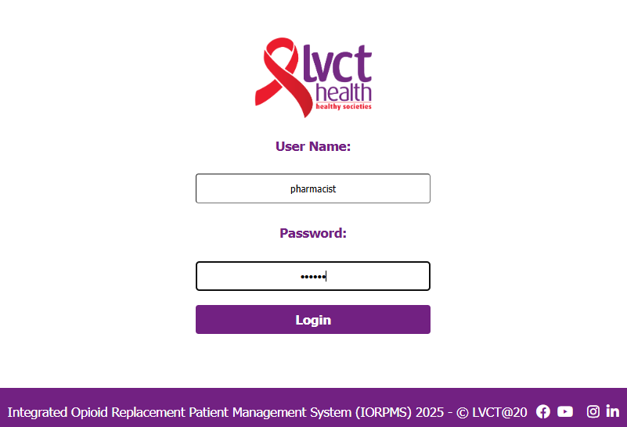
 | This is the landing page:  Click on profile tab | 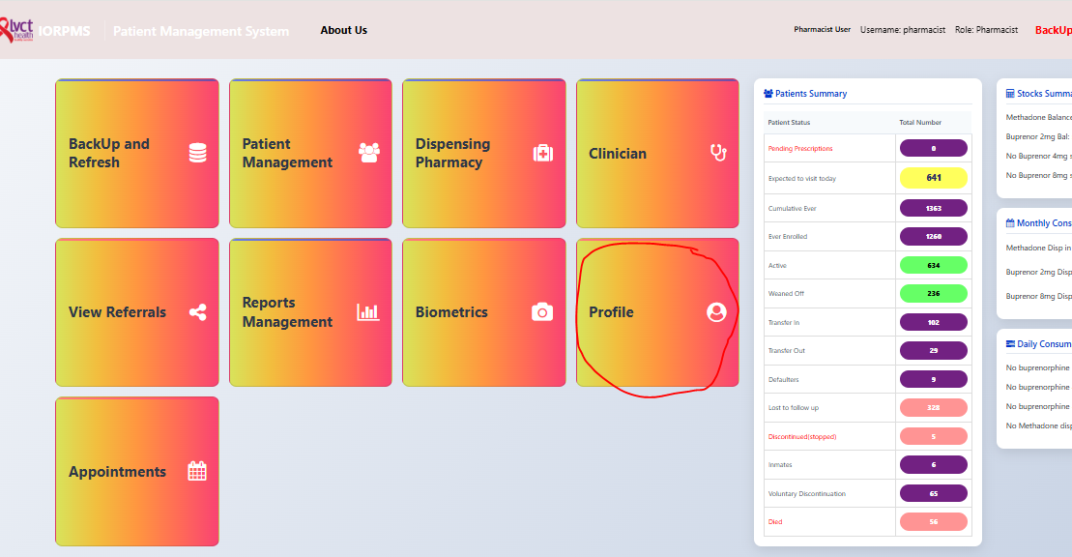
 | Change your password by clicking on ‘change password’ | 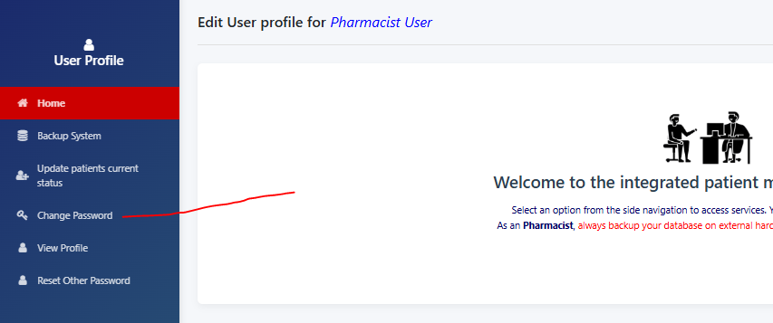
 | Enter old password ‘123456’ then enter your new password that matches e.g. 987456321 and repeat and click “UPDATE PASSOWRD’ a success message will be displayed and logged out to login screen | 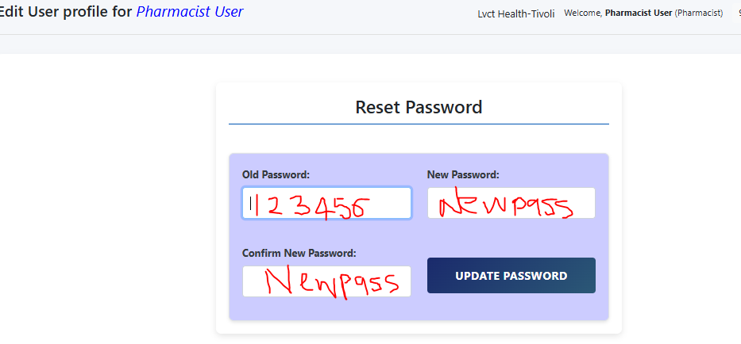
 | Log in with your username and new password

